Significant Figures Problem Set  Chem B11 | Name_____________________________________  Lab Period_________________________________

- How many significant figures are in the following numbers?
6.06 g |  | 1000 cars |  | 85% |  | 1.06 qt/L
25.0 mL |  | 1.05 x 10⁵ m |  | 25 tablets |  | 45 miles/hr
0.000059 m |  | 1001 in |  | 10250. mcg |  | 24 hrs/day
105100 lb |  | 30.8 mg |  | 5.6 x 10⁻⁷ g |  | 1000 m/km

- Scientific Notation. Keep the same number of significant figures.
2.74x10⁻⁴ |  | 4.06x10⁴ |  | 100010000
5.01x10⁶ |  | 3.2x10⁻² |  | 0.000700
1.1x10⁻³ |  | 6x10⁻⁶ |  | 50.0

- Calculations: do the following math problems giving the answer with the right number of significant figures. Round your answers in the right way according to sig fig rules.
- 11.1 + 12.06 + 10 = | g. 25.0 x 10.00 =
- 12500 + 2330 - 1000 + 10.6 = | h. 66/100.9 =
- 0.0045 + 0.04602 – 0.0000020 = | i. (15.2 x 23)/26.34 =
- 4 x 10⁻³ x 3 x 10⁻² x 2 x 10⁻⁴ = | j. 6.21 x 10⁴⁰/(4.678 x 10⁻⁵⁰)
- 8 x 10²/(2 x 10⁻⁷) = k. | $$\frac{2.345x{10}^{2} x 1.1x{10}^{3} x 9.1x{10}^{-1}}{(4.678x{10}^{4} x 6.21 x {10}^{5})}=$$
- 9 x 10⁻⁴ x 3 x 10⁷/(1.2 x 10⁶) =

- What do you see? Read the following measurements with the right number of significant figures. (the scale is in mL)
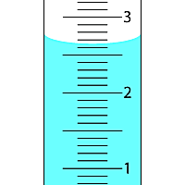

Reading:_________________
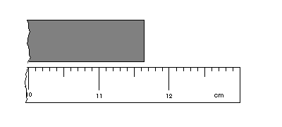
Reading:__________________
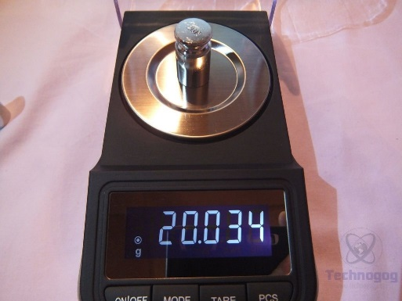

Reading:____________________

